FSD TASK 1 - 04/05/2020

1. Explain the working of the below code and justify the o/p?

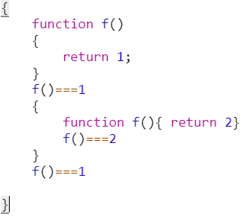

Answer- Here, After writing this JS code when we press enter it shows true in console because f()===1 and its type is also same. And when we calling function f() it returns 1 and coming out of the code. Not going inside other block because it is return from first block only.

